Analyzing

Issue Causality

This course describes how you can use the Causality Instance graph to perform investigations. The course also describes how to analyze issues in the Causality View and Timeline View.

Course Objectives
After completing this course, you should be able to:

- Analyze issues in the Causality View
- Describe node types in a causality graph
- Explain an attack region in a causality chain
- Perform actions using the shortcut menu of a process node
- Navigate over a process tree
- Obtain event data for a process node
- Analyze issues in the Timeline View

Lesson Topics
We recommend that you take the lessons in numerical order, but you can use the menu for quick access to any lesson at any time.
Click the lesson title buttons to go to each lesson. You can also navigate the course using the navigation arrows below or the menu bar at the top left of the screen.
Lesson 1: Causality View
Lesson 2: Causality Chains
Lesson 3: Causality Instance Graph
Lesson 4: Timeline View

Causality

View

This lesson presents a scenario about how you can use Cortex to identify the causes of an attack and provide remediation solutions.

The Causality View
The Causality View provides a powerful way to analyze and respond to issues. The scope of the Causality View is the Causality Instance (CI) to which this issue pertains. The Causality View presents the issue and includes the entire process execution chain that led up to the issue.
This example shows the causality view of an issue detected by the XDR Agent and shows a graphical representation of the Causality Instance along with other information and capabilities to help to conduct an analysis. Clicking on the nodes displays information in the Information Overview pane related to that node.
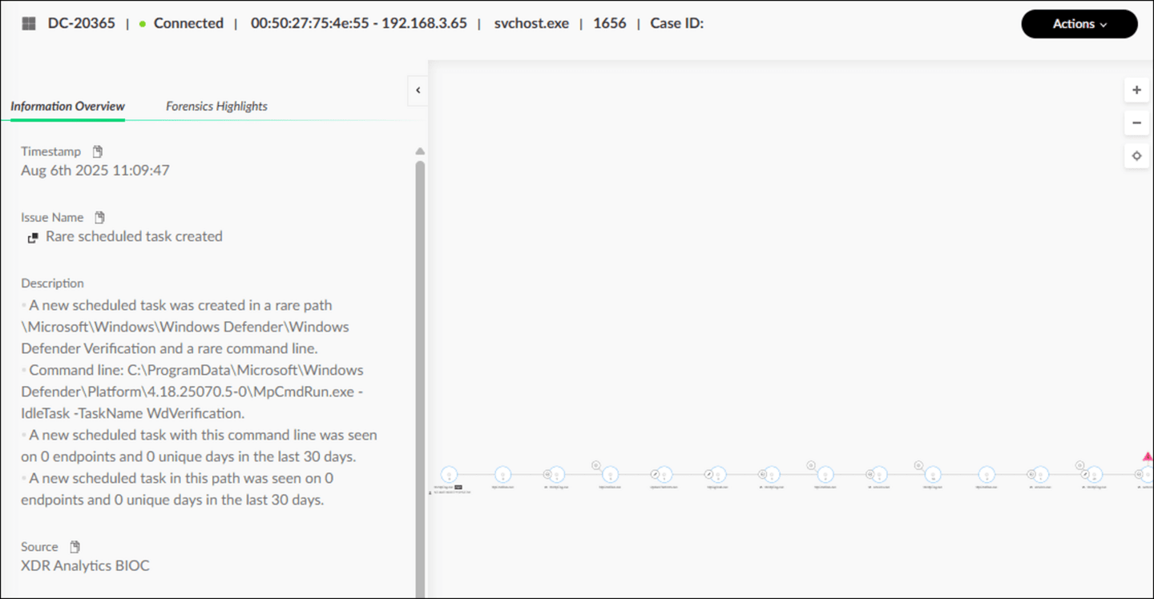

Events Table View
The Events table displays up to 100,000 related events for the process node which matches the issue criteria that were not triggered in the issue table but are informational. The Prevention Actions tab displays the actions that Cortex takes on the endpoint based on the threat type discovered by the agent.
Click the image to enlarge it.
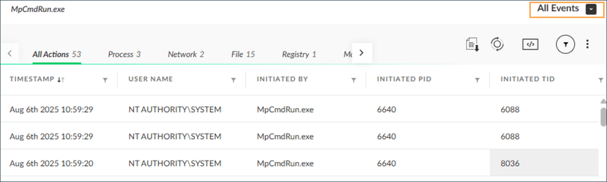

Forensics Highlights
The Forensics Highlight pane shows key activities and artifacts from a threat.
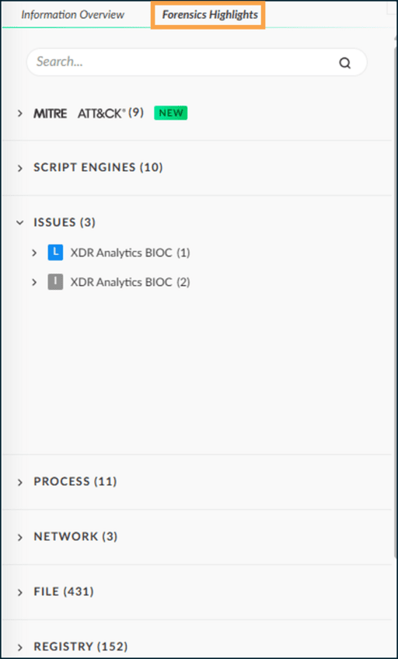

Open Card Actions
The Causality View can be opened using the Open Card action of an issue in the Cases view.
To open the Causality View of an issue in a new tab, right-click the issue and go to Investigate Causality Chain > Open Card in new tab. Click the image to enlarge it.
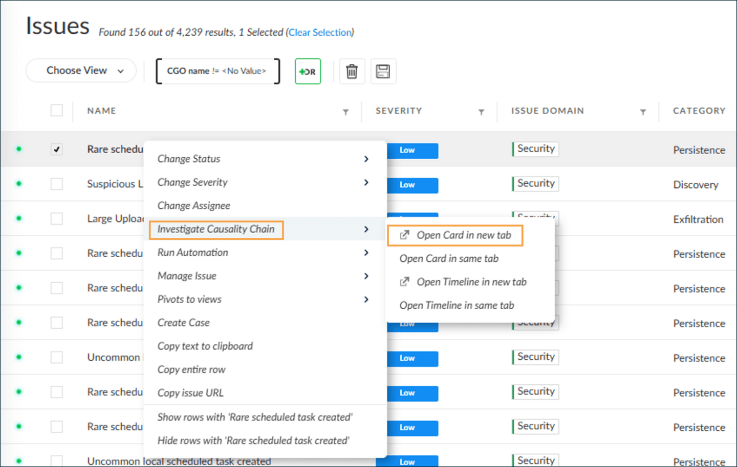

Open Card Actions Availability
Open Card is not an option for every issue. The availability of the "Open Card in new tab" and "Open Card in same tab" depends on whether the issue is stitched (correlated to logs and thus enhanced). Click the tabs for more information about stitched and non-stitched issues.
Stitched Issues
The Open Card actions, indicated by the green dot in the first column of the image, are always enabled for stitched issues.
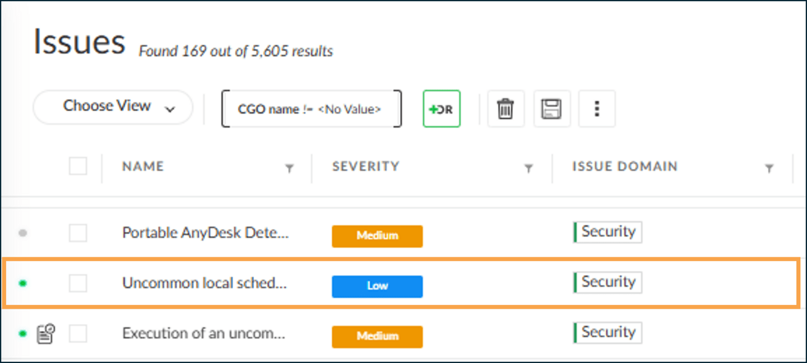
Non-Stitched Issues with Limited Information
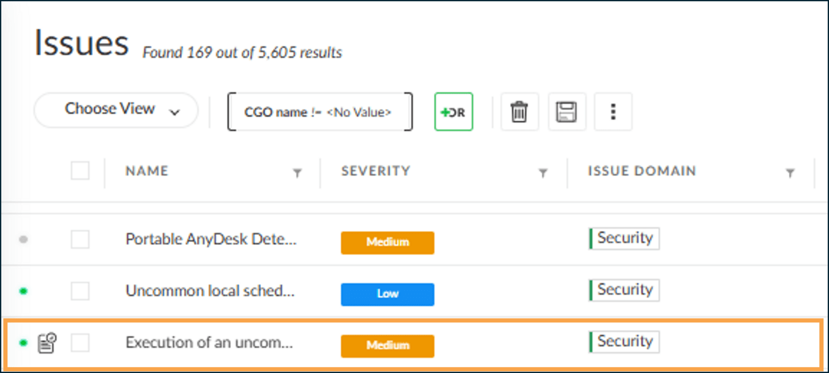
Non-Stitched Issue with No Information
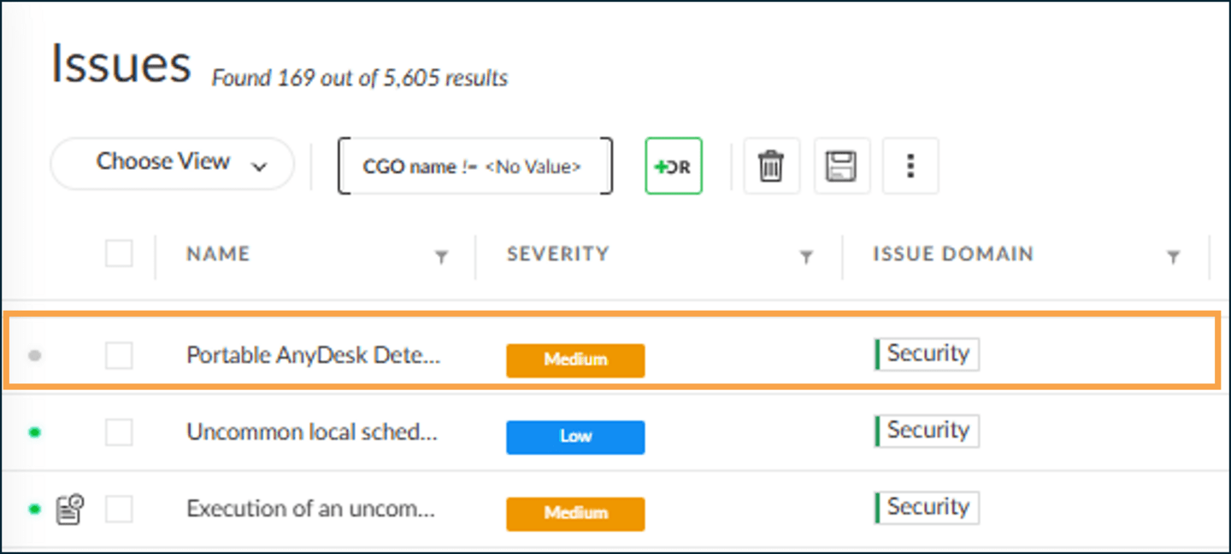

An Attack Scenario
A security operations center (SOC) analyst continuously monitors issues and cases in the Cortex management console. The following is an example of an attack scenario about an issue caused by an end user and the investigation that follows.

Investigation Areas
To learn more about the attack, the analyst categorizes the investigation as follows:


Identify all other processes involved in the attack, along with their full execution chains (parent-child relationships), command line arguments of processes, and filenames, including full paths. Also, obtain the verdicts about the processes from different threat intelligence sources.
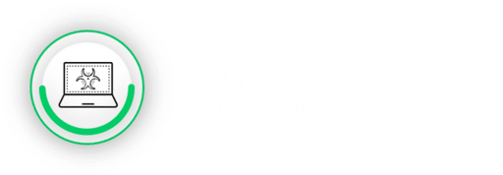

Identify malicious processes that may have modified some files, created new ones, or even deleted some. Check if Windows registry keys were changed, created, or deleted. Identify network interfaces and the type of traffic that could have been sent or received.


Identify the timelines of the attack events over the period of the activity that can be useful for the investigation.

Attack Scenario and Investigation Example
Let's look at an attack scenario that generates issues and investigation by an analyst. Click the images to enlarge them.

End User Action Generates an Issue
An inexperienced, unsuspecting end user double-clicks a file on their endpoint, causing a malicious script in the file to run. The Cortex XDR agent runs on the endpoint and blocks the attack encoded in the script.
The agent also displays the Cortex Prevention Issue window with details of the blocked attack to notify the user.
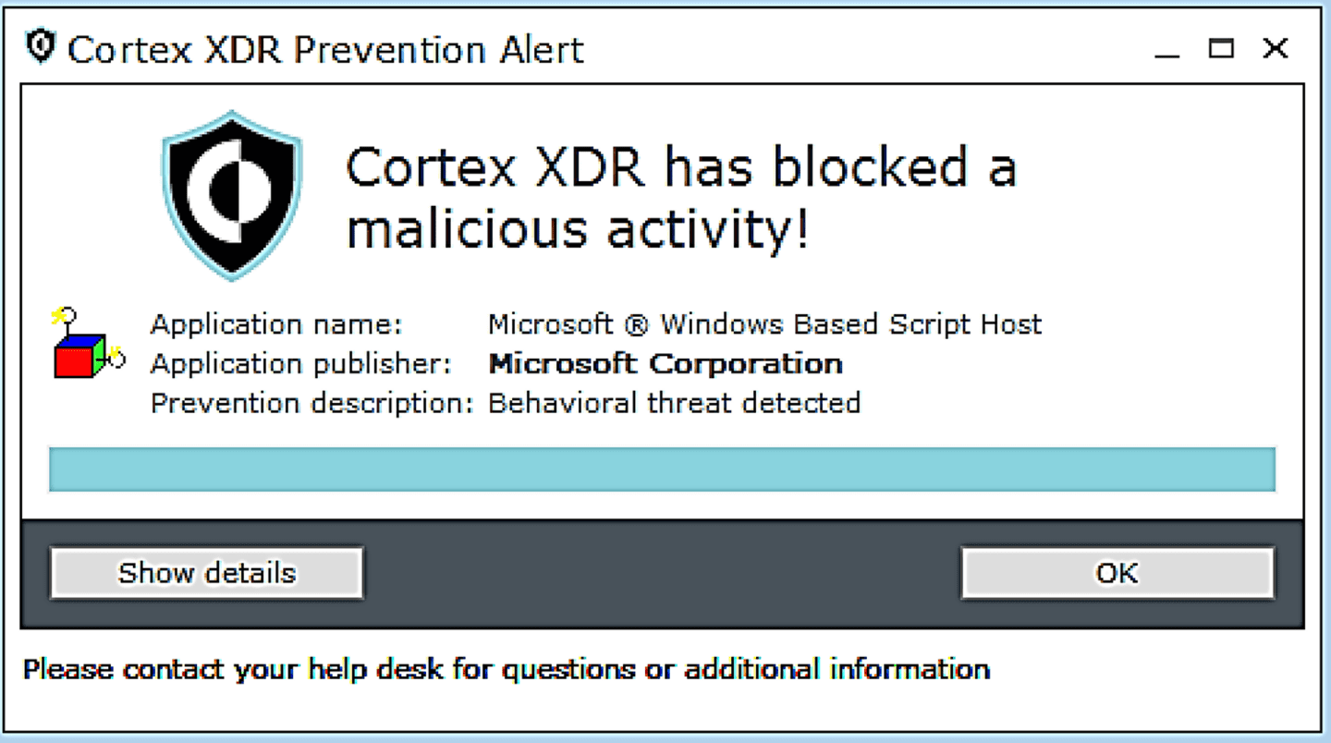

Investigation Action
An analyst working on the issue realizes that the script was of the type Visual Basic (VB) script, which was calling upon some of the legitimate Windows applications. The script is simplified, as shown in the image.
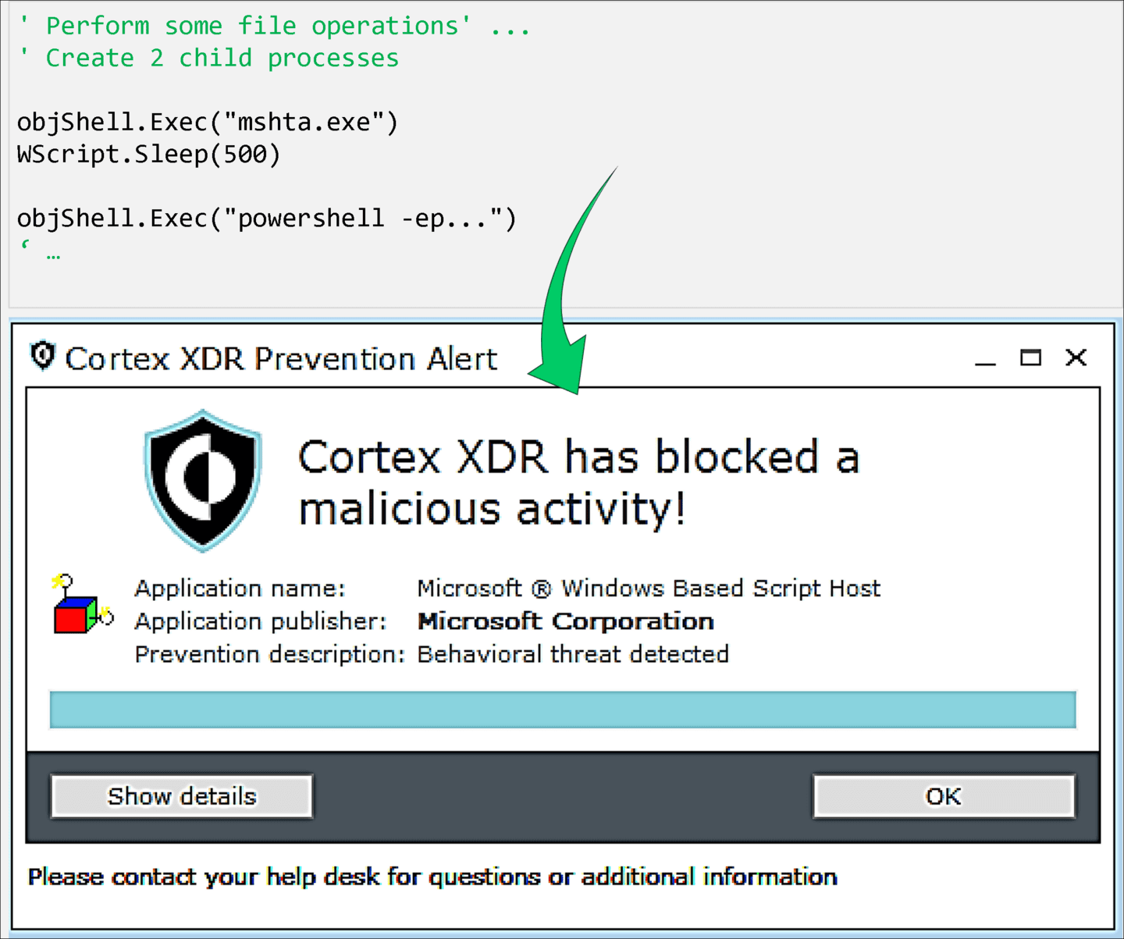

Investigating Issue Attributes
The analyst notices some issue attributes (as shown in the table) that indicate the root cause of the attack was the "wscript.exe" process, which is a legitimate Windows application known as the Windows Script Host.
The analyst starts to ask whether this legitimate application was the root cause of the threat. The analyst also tries to find other attack details to identify the attack, write a damage report, and provide remediation actions.
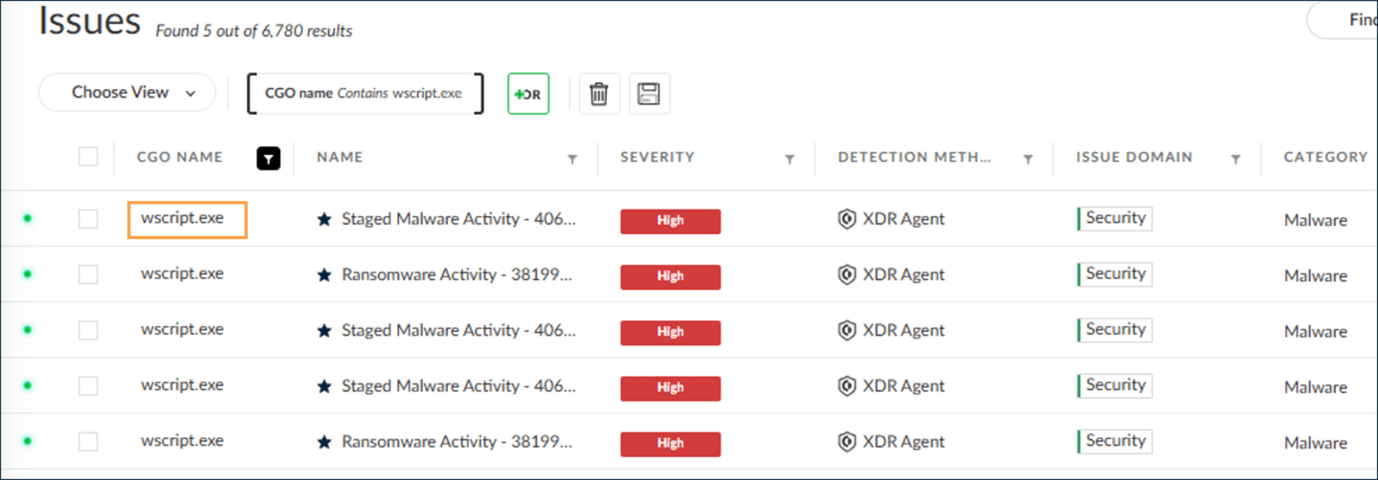

Causal and Timeline Analysis of Issues
Issue investigations require causal and timeline analysis of issue.
- 
- Causal Analysis
- Causal analysis is a type of statistical analysis of event data (issues and logs) to decipher the cause-effect relationships between attackers (malicious processes) and victims (computing resources and assets).
- 
- Timeline Analysis
- The Timeline provides a forensic timeline of the sequence of events, issues, and informational behavioral indicators of compromise (BIOCs) and correlation rules involved in an attack.

Causality

Chains

This lesson provides an in-depth exploration of the attack region and the formation of causality instances, offering insights into how Cortex identifies and manages processes involved in cyber threats.

Attack Region
An attack region consists of a group of processes within the hierarchical process tree that are involved in an attack. One of the primary challenges in this context is distinguishing which specific processes were part of the attack.

Determining the Attack Region
To identify the boundaries of the attack region, Cortex employs advanced causality analysis on all collected data stored in the Cortex instance datasets. This analysis leverages correlation techniques powered by machine learning.
The outcome is visualized in the Causality View within the Cortex management console. Click the image to enlarge it.
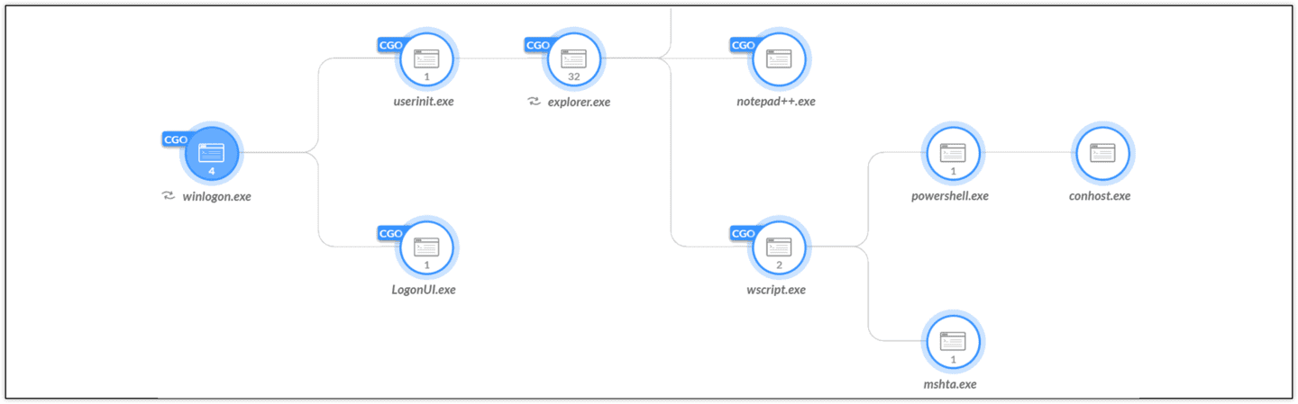

Causality View and Attack Zone
The highlighted area in the Causality View represents the attack zone, which includes all processes directly or indirectly involved in the attack. This visualization helps in understanding the scope of the attack and the processes responsible.
The image illustrates the attack region for a specific example, showing the processes involved in the attack. It is important to note that all processes within this region are responsible for the attack and are terminated by the Cortex XDR agent to neutralize the threat. Click the image to enlarge it.
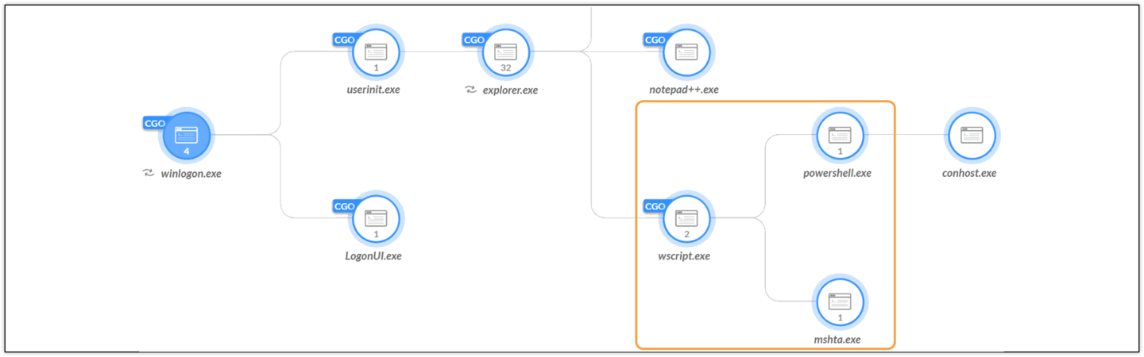

Causality Instances
Stitched issues can reveal all the processes involved in suspicious activity. After the responsible processes are identified, their operations over the resources can easily be obtained from the enhanced endpoint data.

Causality Instance (CI)
Each causally-related process group is called a causality instance (CI), also known as a causality group instance, a causality chain, or a causality execution chain. A causality instance is identified with a CID.
A causality instance object might include information about the process-resource interactions and the issues, depending on the existence of an attack.
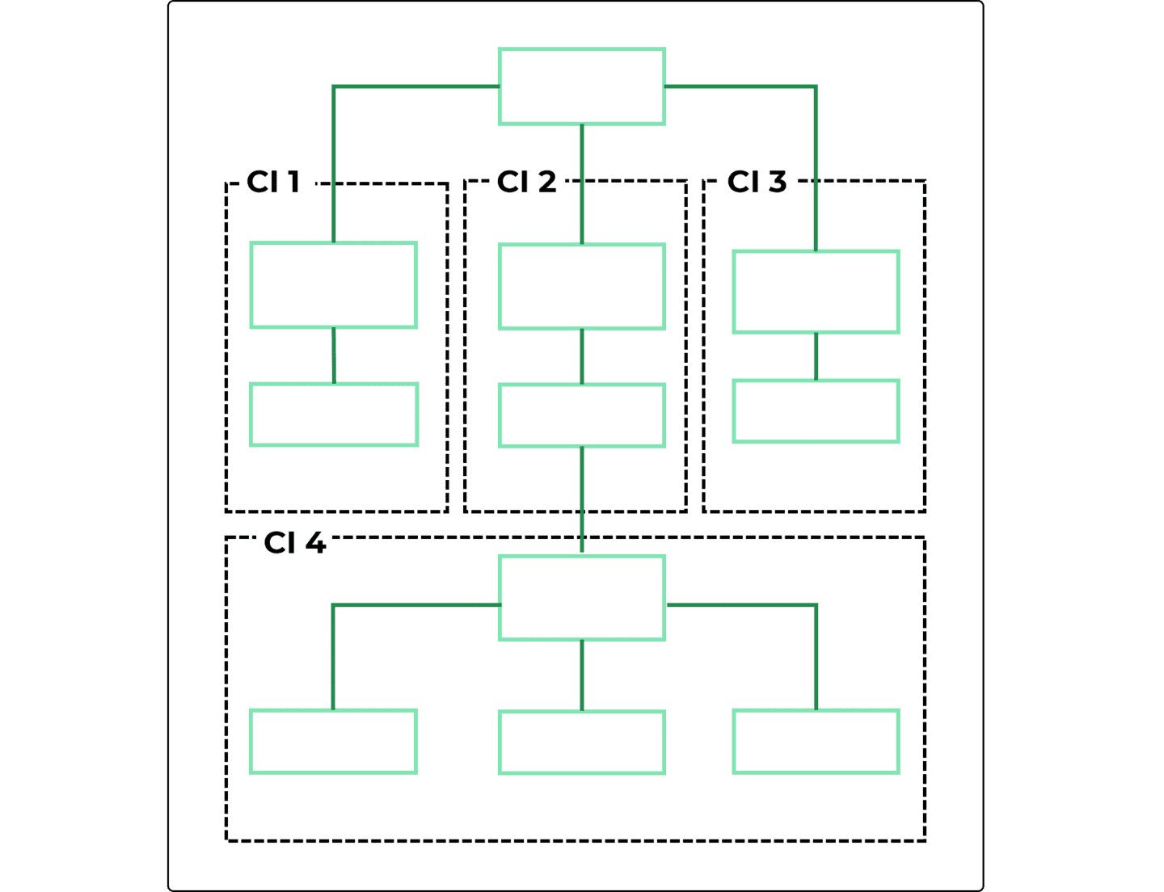

Causality Group Owner (CGO)
In the case of an attack, Cortex XDR agent terminates all processes in a causality instance, which are considered responsible for the attack.
However, it is important to identify the root cause of every issue during threat investigation. In the case of a causality instance, the root cause is the group’s root process, which is called a CGO. A CGO is the ancestor of all processes in the causality instance. A CGO also is identified with the same ID, the CID.
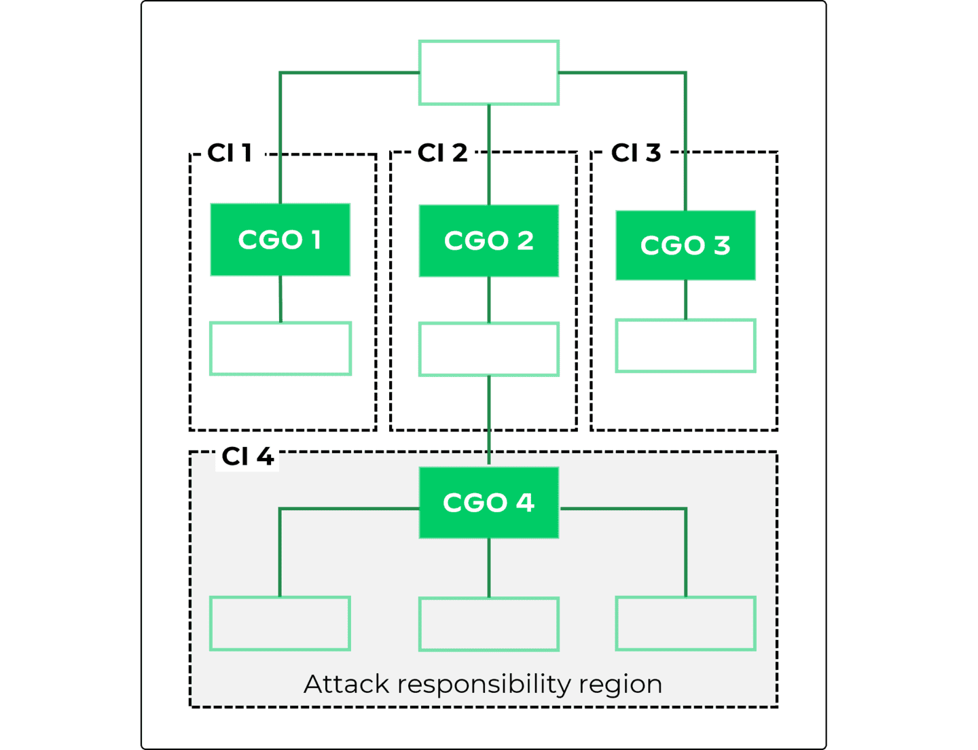

Formation of Causality Instances
Cortex leverages predefined, learned processes called spawners and final spawners to enhance security monitoring through causality instances. These processes are updated regularly via content updates to ensure accurate threat detection and response.

Spawners
To effectively divide the process tree into distinct causality instances, Cortex XDR employs special marker processes known as spawners. These spawner processes are identified using advanced machine learning techniques by the research team. When new spawners are discovered, they are added to the endpoint list through content updates.
During runtime, as the Cortex XDR agent monitors enhanced endpoint data, it identifies every immediate child process of a spawner as a CGO (Causality Group Object). The agent then constructs the causality instance starting from the CGO and includes all descendant processes, excluding other CGO processes.
Common examples of Windows spawners include:
explorer.exe
msiexec.exe
services.exe
winlogon.exe

The graphic illustrates the relationship between spawners and CGOs. It shows spawners 1 and 2 with CGOs 1, 2, 3, and 4, highlighting how the process tree is divided into causality instances.
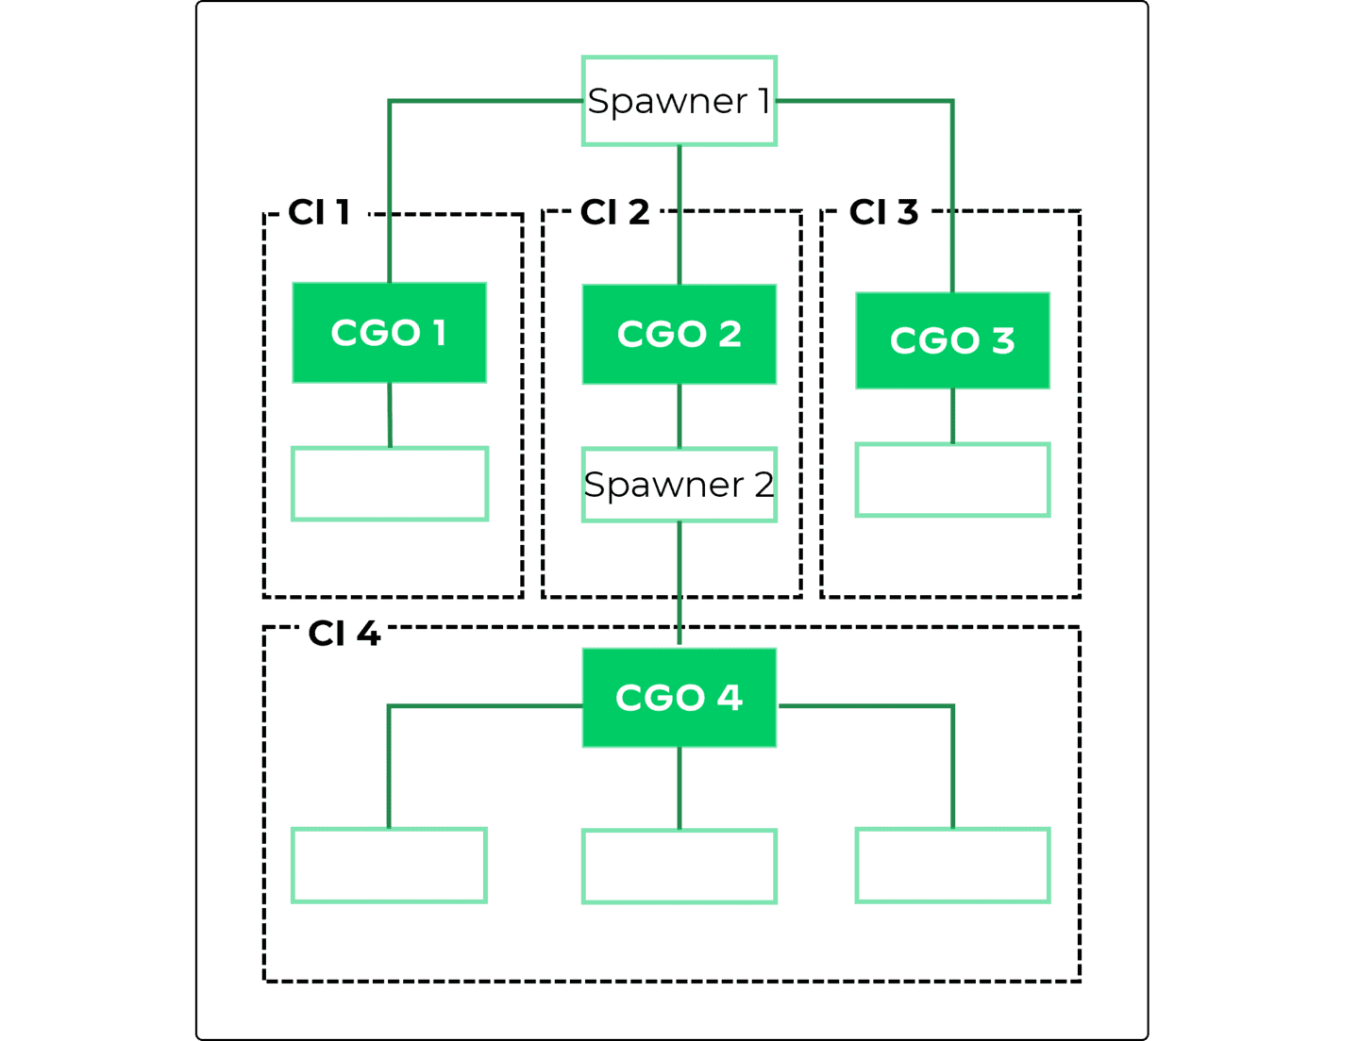

Final Spawners
In the context of a single attack, multiple causality instances can be linked. These linked spawners, which may result in dependent causality instances, are identified as final spawners during threat research.
To break any dependencies, the Cortex XDR agent downgrades all potential spawners within the descendant hierarchy of a final spawner to normal processes. This ensures that the causality instances remain independent.
Common examples of Windows final spawners include:
chrome.exe
firefox.exe
iexplore.exe

This graphic demonstrates the finalization process, showing the final spawner 1 with spawner 2 CI 4 and CGO 4 removed, indicating the downgraded status of dependent spawners.
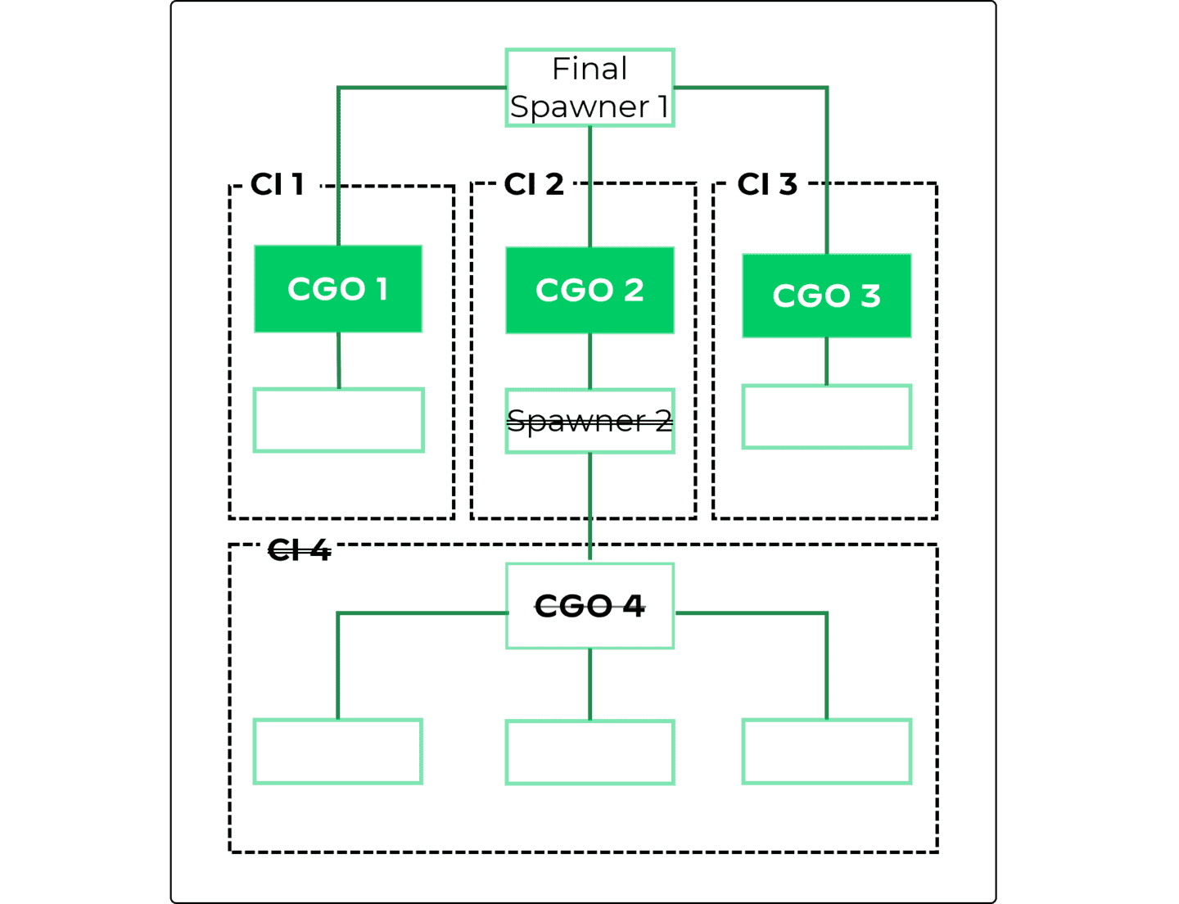

Causality

Instance Graph

This lesson describes the process nodes in the Causality Instance (CI) graph and the right-click actions you can take on a process node.

Process Nodes Legend
A process node is symbolized by a circle and provides information about the number, Causality Group Owner (CGO) tag, username, and process node name of the nodes in the CI. You can right-click process nodes to take actions.
Click the tabs for more information about process nodes. Click the images to enlarge them.
Username
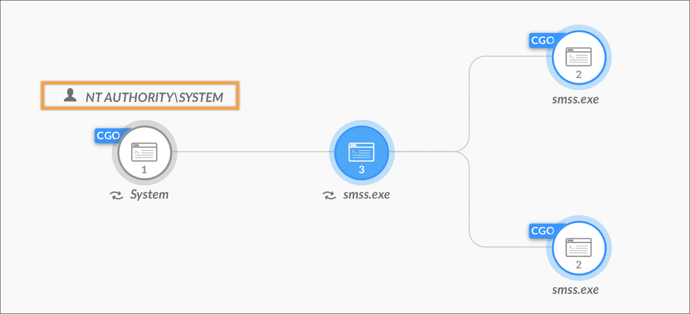
Selected Node
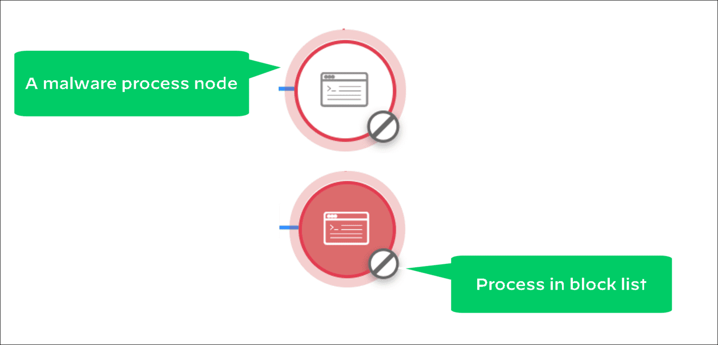
Node Number
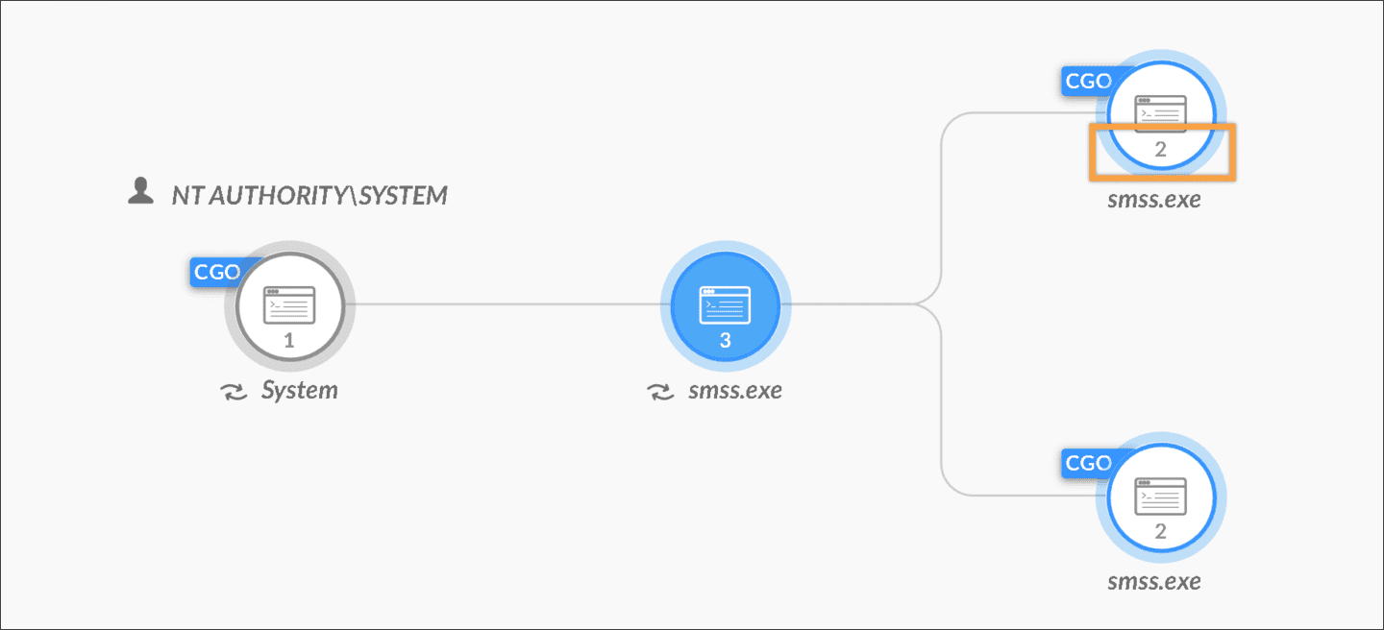
CGO Tag
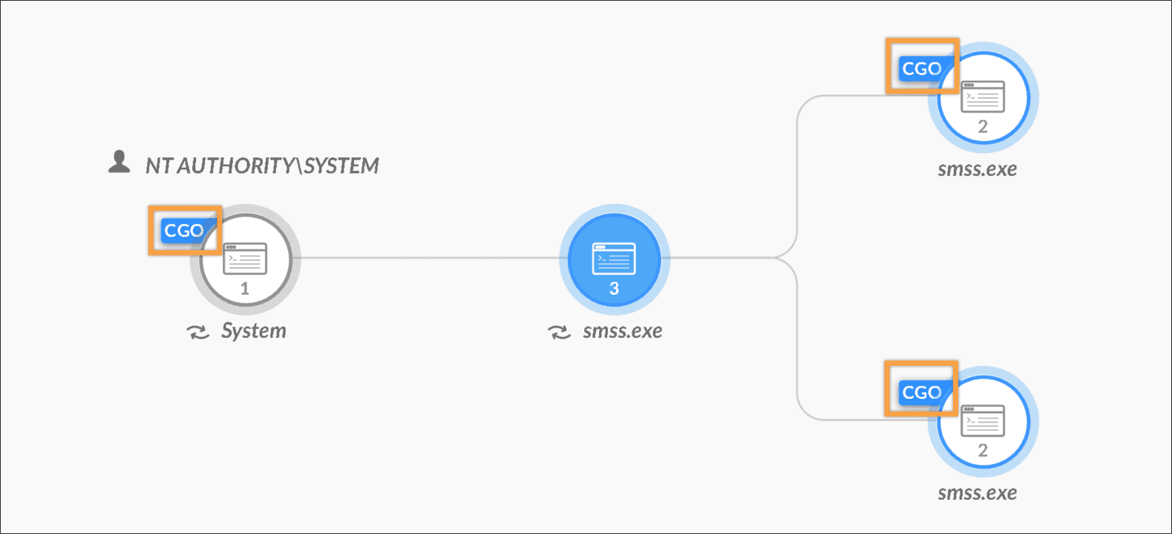
Process Node Name
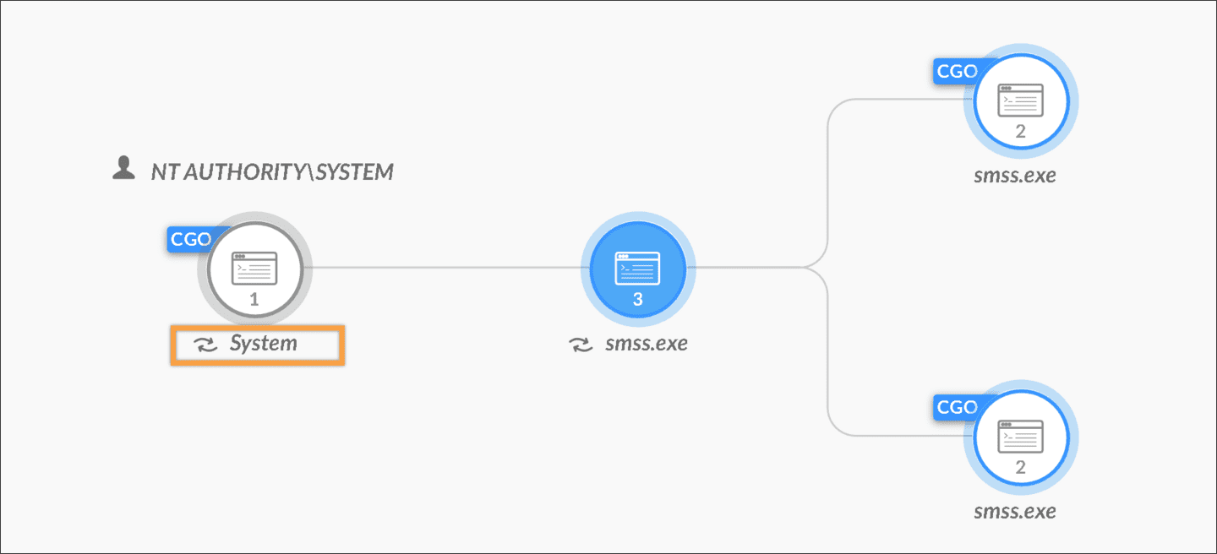

Process Nodes Legend
The color of the circle indicates the WildFire verdict of the process.
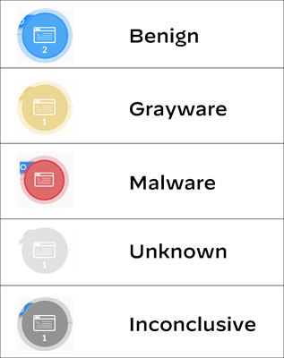

Demo: Process Nodes Actions
Watch this demonstration about the actions you can take on process nodes in the Causality Instance graph.

Issue, User, and Injection Nodes
You may find other node types, such as issue, users, and injection nodes.
Click the images to enlarge them.

Issue Nodes
While a process node represents a single operating system process, an issues node is attached to a specific process node that caused the issues to be generated. An issues node contains one or more issues, but has no child nodes.
Each of the issue nodes in the example are connected to a process node. Their symbols (icons) are different, indicating the issue sources.
An issues node has no right-click action, but you can click it to get information about the issues it contains in the black node attributes pane.
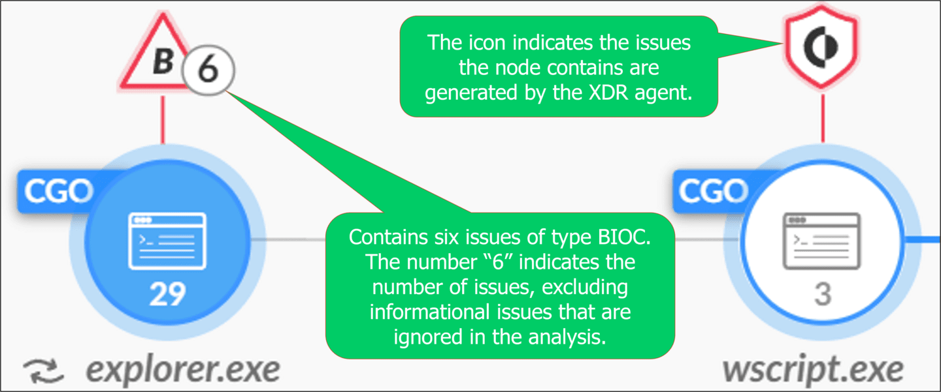

User Node
A user node represents users in the CI graph and displays detailed user information, such as active directory group, organizational unit, role, logins, hosts, issues, and process executions associated with the selected user in the events table.
This information is collected by Cortex Identity Analytics, which requires a Cloud Identity Engine instance paired with the Cortex instance and an Active Cortex Analytics Engine.
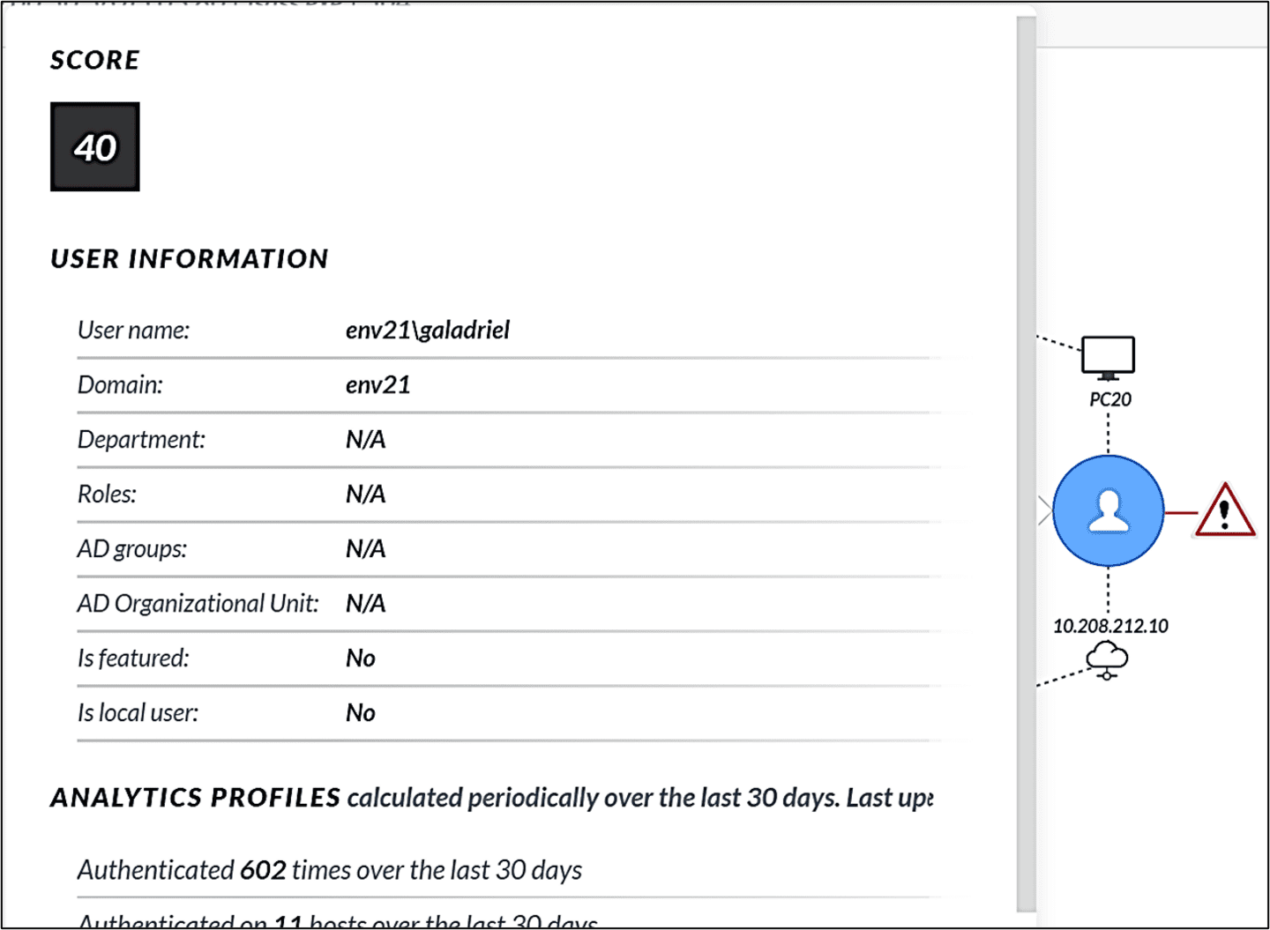

Injection Node
An injection node can be a subtype of the process node. It is of the process node type with some additional information about code injection and Remote Procedure Call (RPC) calls. In such remote executions, the process node shows an embedded icon to indicate that a RPC or code injection has occurred on that node.
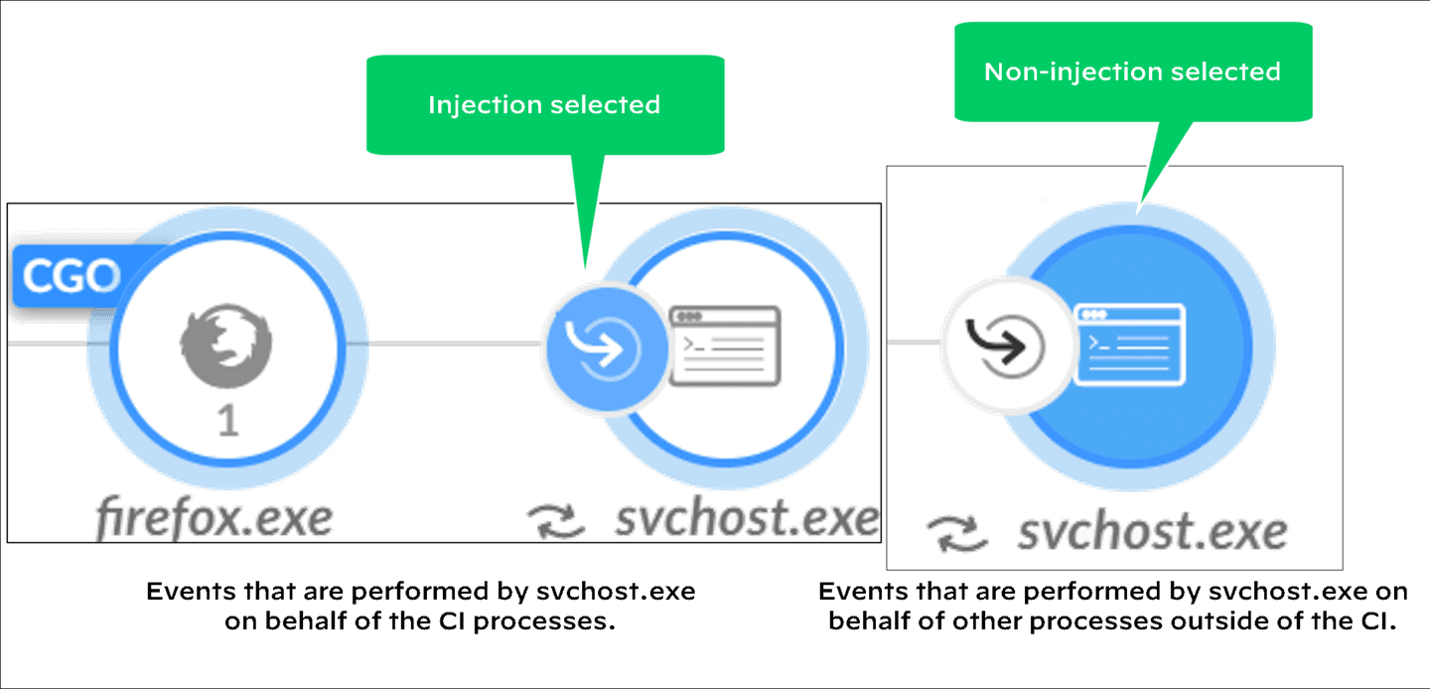

Injection and Non-Injection Events
An injection (process) node has two different parts to click on: injection and non-injection (usual process). Each part has its own event tables, but both point to the same operating system process. For example, a legitimate OS kernel process that can run code in different threads running at the kernel level on behalf of user-level processes. Such user-level process requests may or may not be related to attacks. Click the tabs for more information about injection and non-injection events. Click the tabs to view more information about injection and non-injection events.
Injection Events
Non-Injection Events
Non-injection (usual process) events are performed by the process svchost.exe on behalf of any other processes that are not part of causality instance. These events are not related to the attack.
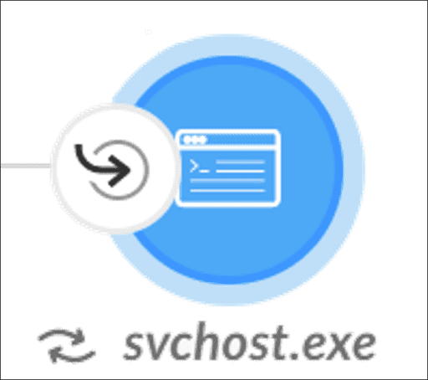

Additional Information Views
There is issue-specific information that allows for better analytics investigation. This includes identity, cloud and other information.

Information Overview Pane
Clicking on nodes can bring up additional information in a right side pane. Click the image to enlarge it.
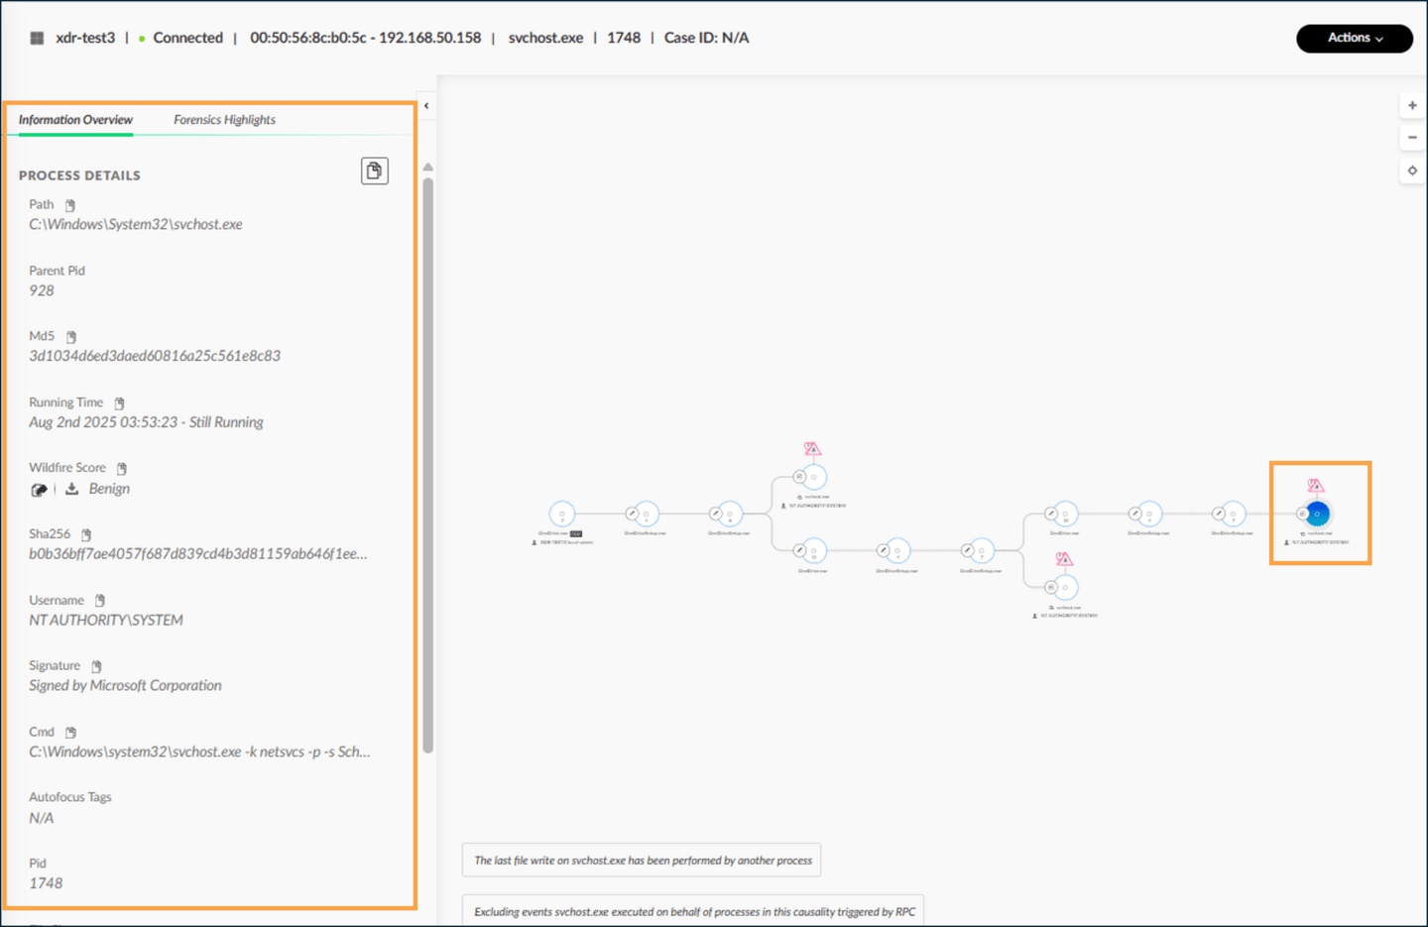

Key Identity Information from the Application
You can view additional information in the table at the bottom of the page. The additional information shown here not only displays the endpoint, but also the activity that is being done from the identity in the SaaS application. Click the image to enlarge it.
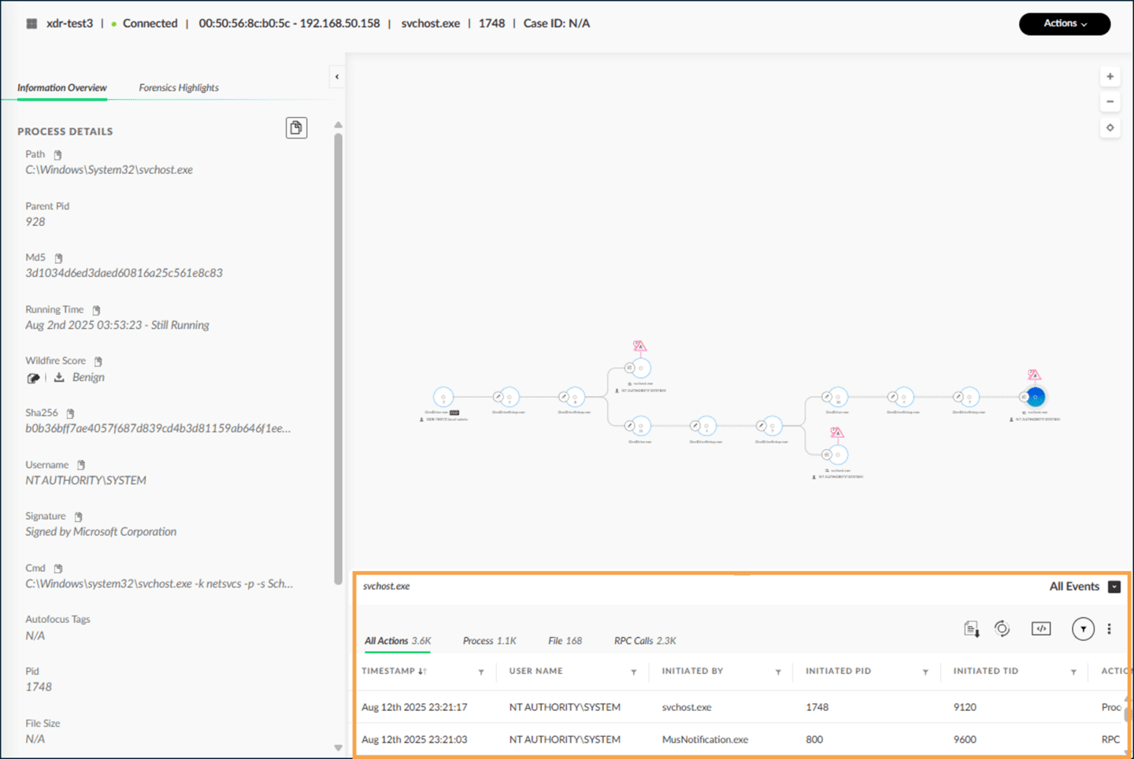

Cloud Causality Chain Views
You can view causality chains for cloud-related events. This data is visualized using data coming from the cloud provider. On the left, the information overview pane shows details from the cloud. The bottom section shows the cloud related event. Scrolling to the right shows more fields with cloud event information.

Timeline

View

This lesson describes how you can analyze stitched issues in the Timeline View. It also describes the various sections of the Timeline View.

Timeline View Overview
In the Cortex management console, the Timeline View page is a single pane of glass for viewing the results of an issue timeline analysis. It provides a timeline analysis of stitched issues, which reveals the time sequence of attack components—ranging from informational BIOC issues, process executions, outbound or inbound connections to critical issues.

Timeline View Layout
The Timeline View page has two panes—at the top and bottom of the page— that is separated by a draggable divider. You can drag the divider to adjust the pane sizes. Click the images to enlarge them.

Upper Pane
The upper pane contains the following sections:
Events: The activities section lists activity types in the vertical axis.
Time scale: The top horizontal timespan pane displays time scale in the horizontal axis.
Event Nodes: The third section, like a rectangular coordinate system, is for showing matching activities at points in time as clickable nodes.
Processes: The top left-corner pane shows the selectable list of processes in the causality instance that you can select to narrow down the information shown in the timeline view.
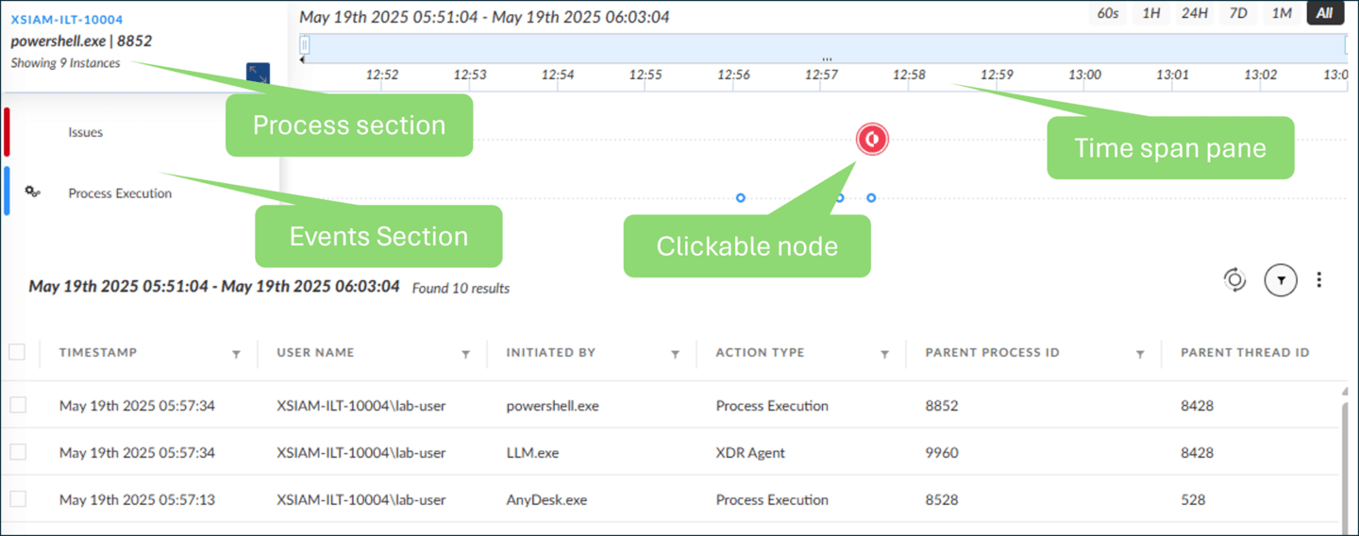

Lower Pane
The lower pane shows a table of events associated with the selected (clicked) node in the upper pane. The table lists the types of events, such as XDR agent issues, BIOC issues, or process executions.
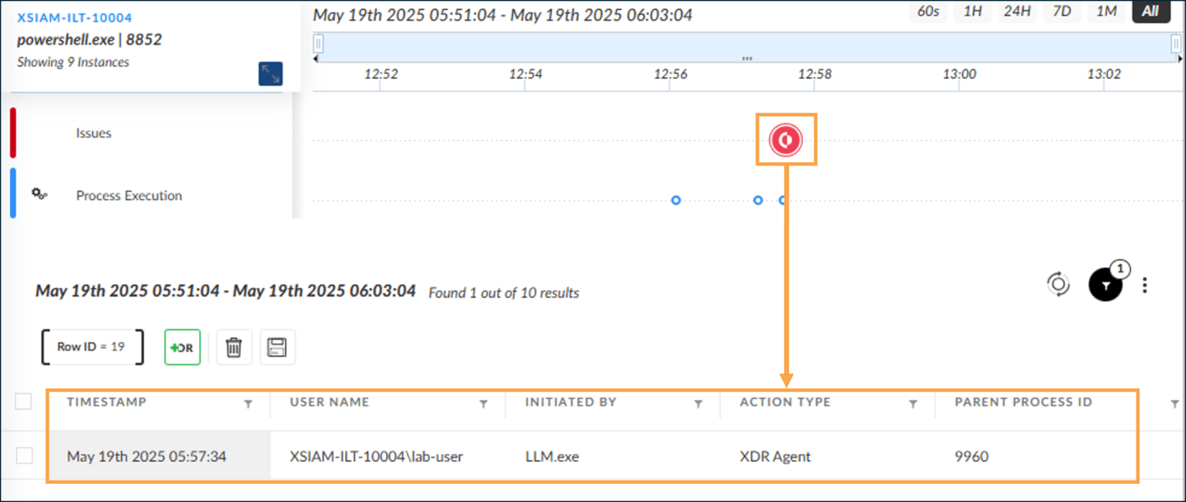

Timeline View Sections
You can use the time scale, the events section, and the event timestamps to view events in the Timeline View.
Click the images to enlarge them.

Timescale Section
By default, the time scale displays a 24-hour time period adjusted to the start time of the investigation. You can drag the timespan slider to shift the 24-hour window backward or forward.
The pane also provides other time window duration buttons. For example, clicking the 7D button sets the time window to 7 days. You can expand the time window to a custom duration by pulling the slider. In the example, the time window duration is set to 24 hours, starting at 00:00.
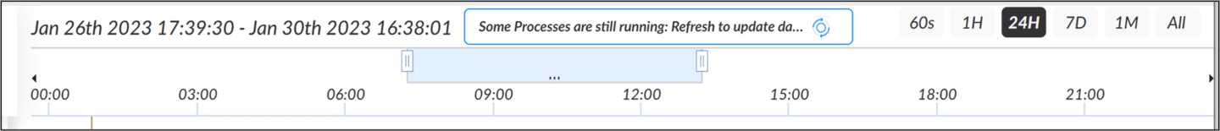

Events Section
The left pane lists all types and high-level categories of events identified during the attack cycle. The three high-level categories are Cortex issues in red; BIOCs and correlation rules issues in orange; and other informational activities and events in blue, as shown in the image.
The three vertical bars show the placement of categories. In this example, the orange bar in the middle shows two issues for the Evasion and Discovery types.
The blue bar (at the bottom) groups the Process Execution. This category can also include activities such as incoming and outgoing connections.
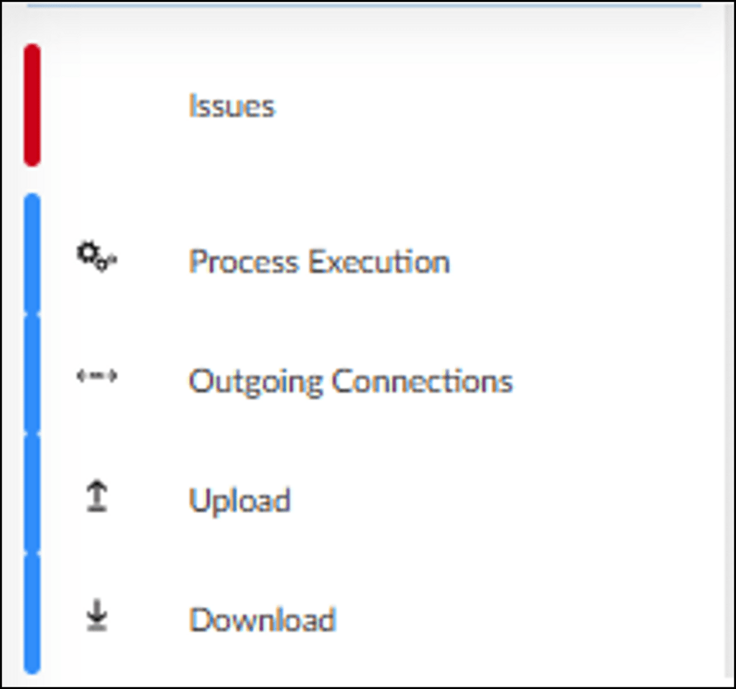

Events Time Section
The horizontal projection (from the events) and the vertical projection (from the timeline) intersect at a point, which represents an event node. The shape and color of the event node indicates the type and severity of the event. For example, an Evasion event icon has a down arrow, as shown in the image.
The severity is indicated by a color. For example, dark red is for Critical, red for High, yellow for Medium, and blue is of low severity.
An event node is an interactive object. To get brief event information, hover the cursor over the node or click it; the event table is displayed at the bottom pane.
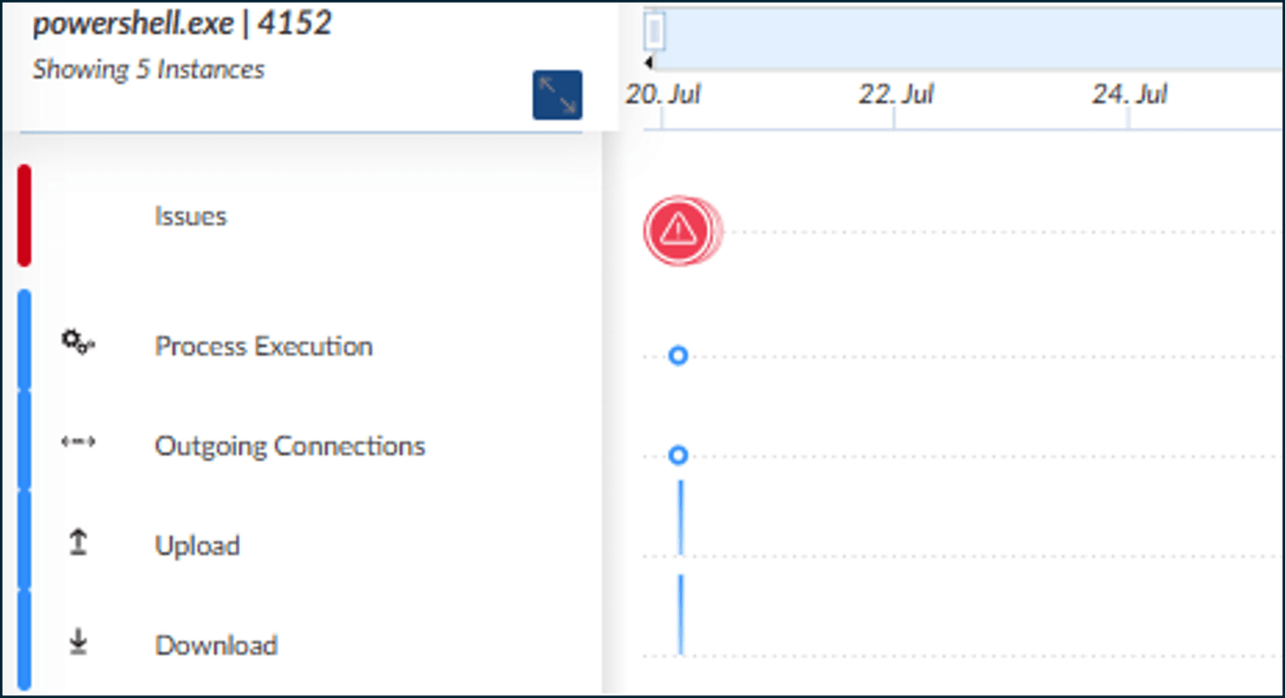

Informational Issues and Process Executions
Informational issues and process executions are represented by blue dots. Click the tabs for more information.
Informational Issues
Process Executions
Process Execution is a type of informational activity that can be maliciously leveraged by attackers. The example shows three Process Execution events that occurred during the attack cycle.
Process executions are represented by blue dots. In the example, the three processes are created by the same Visual Basic script that is outlined as follows:
objShell.Exec("reg /?")
WScript.Sleep(5000)
objShell.Exec("mshta.exe")
WScript.Sleep(5000)
objShell.Exec("powershell -ep bypass -windowstyle hidden –e…”)
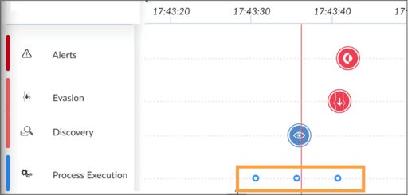

Course Summary
Now that you've completed this course, you should be able to:

- Analyze issues in the Causality View
- Describe node types in a causality graph
- Explain an attack region in a causality chain
- Perform actions using the shortcut menu of a process node
- Navigate over a process tree
- Obtain event data for a process node
- Analyze issues in the Timeline View

